Mathematics – Grade 5

Quarter 1

Remote Learning

Practice and Enrichment Packet

Answer Key



**Quarter 1 Fifth Grade Standards-Aligned Tasks**

Hello SCS Family,

This resource packet was designed to provide students with activities which can be completed at home independently or with the guidance and supervision of family members or other adults. The activities are aligned to the TN Academic Standards for Mathematics and will provide additional practice opportunities for students to develop and demonstrate their knowledge and understanding.

A suggested pacing guide is included; however, students can complete the activities in any order over the course of several days. Below is a table of contents which lists each activity.

**Batting Averages and Dancing Digits**  **2**

**Vacation Plans and The Stopwatch 5**

**Place Value Game and Repeated Decimal Products 8**

**Jayden’s Gym Class and Trendy T-Shirts 12**

**Decimal Sums and Differences 15**

**Ten Times as Much as or One-Tenth of and Less than, Equal to, Greater than 20**

**Using Multiplication Vocabulary and Equivalent Multiplication Expressions 25**

**Represent Decimal Products 30**

**Quiz 35**

|  |  |
| --- | --- |
| **Week 1** | |
| **Fifth Grade Math Standards-Aligned Learning: Batting Averages and Dancing Digits** | |
| **Grade Level Standard(s)** | 5.NBT.A.1 Recognize that in a multi-digit number, a digit in one place represents 10 times as much as it represents in the place to its right and 1/10 of what it represents in the place to its left.  5.NBT.A.3 Read and write decimals to thousandths using standard form, word form, and expanded form (e.g., the expanded form of 347.392 is written as 3 x 100 + 4 x 10 + 7 x 1 + 3 x (1/10) + 9 x (1/100) + 2 x (1/1000)). Compare two decimals to thousandths based on meanings of the digits in each place and use the symbols >, =, and < to show the relationship. |
| **Caregiver Support Option** | Encourage students to draw/use a place value chart when solving  the problems. Encourage students to use the correct language  when reading the symbols > (greater than) < (less than) = (equal  to)to answer questions. |
| **Materials Needed** | Recording sheet, pencil |
| **Question to Explore** | Why did you put each digit in its own place?  The value of a digit in a written numeral depends on its place, or position, in a number. For any number, the place of a digit tells how many ones, tens, hundreds, and so forth are represented by that digit.  How do you know which number is smaller?  Whole numbers and decimals can be compared by analyzing corresponding place values. A number to the right of another on the number line is the greater number |
| **Student Directions** | Read each problem. Respond the directions. |

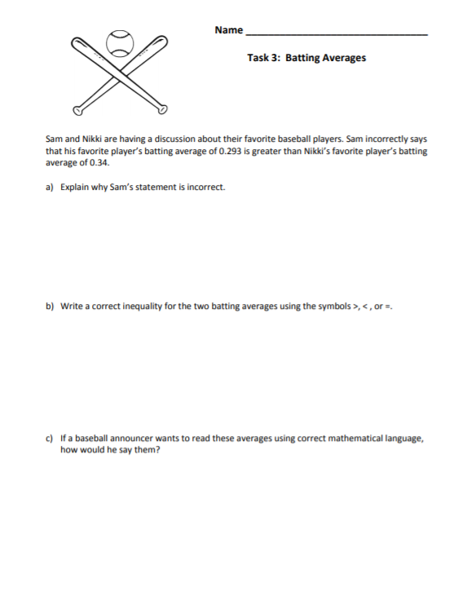

c) Sam’s favorite player: “Two-hundred ninety-three thousandths” Nikki’s favorite player: “Thirty-four hundredths”

b) 0.34 > 0.293 means that 0.34 is greater than 0.293. See reasoning in b). or 0.293 < 0.34 means that 0.293 is less than 0.34. See reasoning in b).

By looking at the tenths place (the largest of the decimal spaces to the right of the decimal), we can see that 3 is greater than 2. Therefore, 0.34 > 0.293.

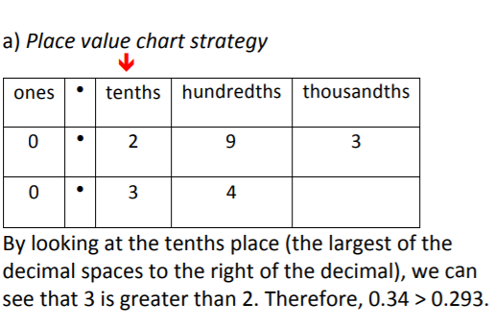

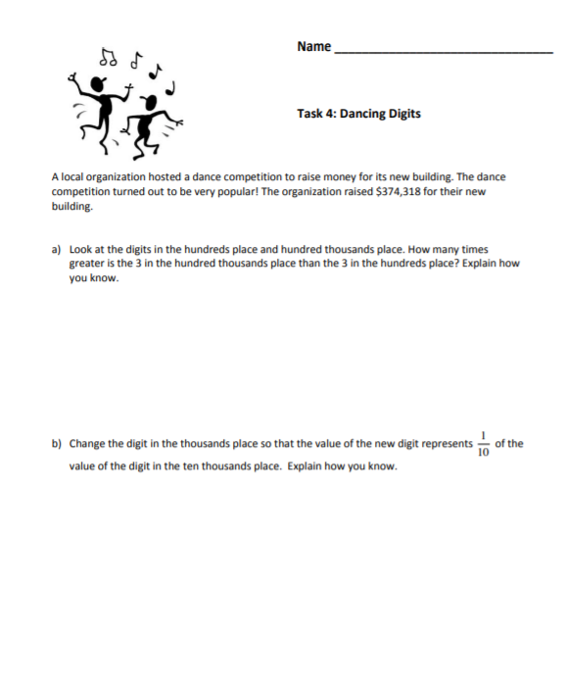

b) Explained with place value chart: A digit in one place represents 1/10 of what it represents in the place to its left. By changing the 4 to 7 in the thousands place is 1 10 the 7 in the ten thousands place.

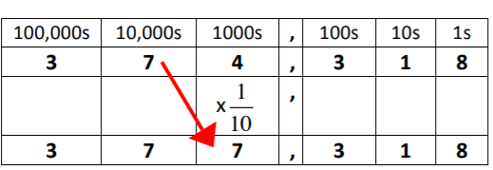

b) Explained with numbers or equations: 70,000 x 1 10 = 7,000 or 70,000 ÷ 10 = 7,000

1. Explained with a place value chart: Each place to the left of the hundreds place is ten times greater than the one to the right. Therefore, the 3 in the hundred thousands place is 1,000 times

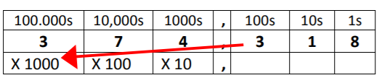

a) Explained with numbers or equations: 300 x 1,000 = 300,000

|  |  |
| --- | --- |
| **Week 2** | |
| **Fifth Grade Math Standards-Aligned Learning: Vacation Plans and The Stopwatch** | |
| **Grade Level Standard(s)** | 5.NBT.A.2 Explain patterns in the number of zeros of the product when multiplying a number by powers of 10, and explain patterns in the placement of the decimal point when a decimal is multiplied or divided by a power of 10. Use whole-number exponents to denote powers of 10.  5.NBT.A.3 Read and write decimals to thousandths using standard form, word form, and expanded form (e.g., the expanded form of 347.392 is written as 3 x 100 + 4 x 10 + 7 x 1 + 3 x (1/10) + 9 x (1/100) + 2 x (1/1000)). Compare two decimals to thousandths based on meanings of the digits in each place and use the symbols >, =, and < to show the relationship.  5.NBT.A.4 Round decimals to the nearest hundredth, tenth, or whole number using understanding of place value. |
| **Caregiver Support Option** | Encourage students to draw a place value chart or base ten  blocks to help them solve the problems. |
| **Materials Needed** | Recording Sheet, pencil |
| **Question to Explore** | Why did you put each digit in its own place? The value of a digit in a written numeral depends on its place, or position, in a number. For any number, the place of a digit tells how many ones, tens, hundreds, and so forth are represented by that digit.  How does this pattern of going right in the place value chart relate to going left on the place value chart? Each place value to the left of another is ten times greater than the one to the right (e.g., 100 = 10 x 10). |
| **Student Directions** | Read each question and solve. |

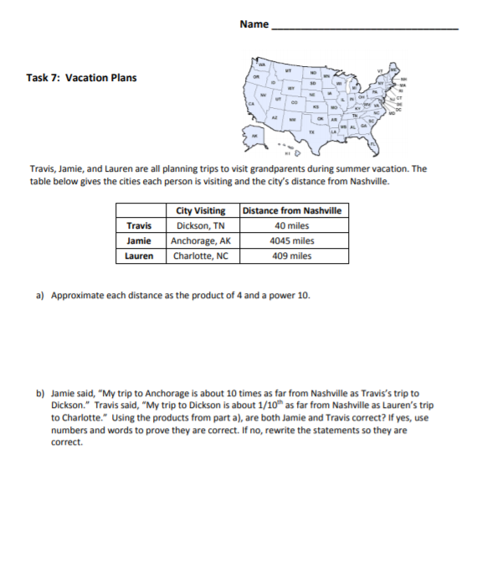

b) Travis is the only one with a correct statement. Since Dickson is approximately 40 miles from Nashville and Anchorage is 4000 miles, 4000 is 100 times 40. When multiplying 40 by 100, the decimal would move two places to the right, becoming 4000. Also, 4x103 is 100 times 4x101 since each increase in the exponent is a multiple of 10. One way to write Jamie’s statement correctly would be: Jamie said, “My trip to Anchorage is about 100 times as far from Nashville as Travis’s trip to Dickson.”

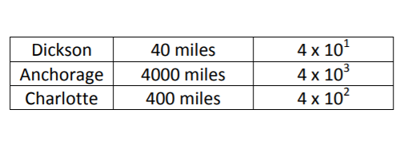

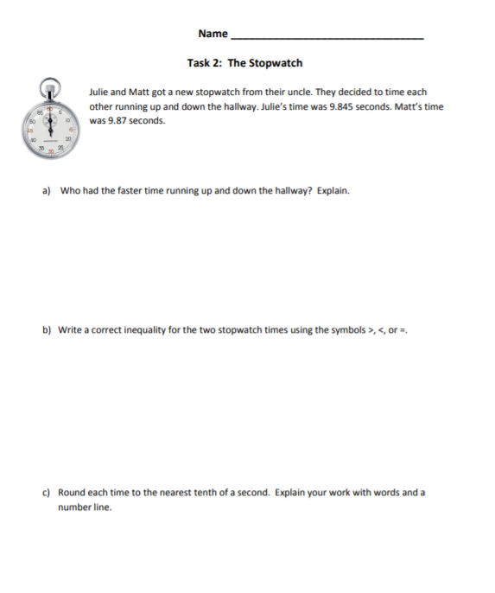

For all solution paths for part a), students should realize that the faster time is the smaller number. a) Base Ten Block Strategy Students should use the following scale to build the stopwatch times:

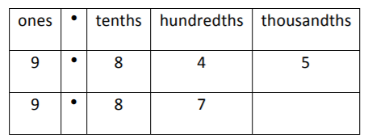

Students should see that 9.845 is smaller than 9.87 because it has fewer hundredths.

c) 9.845 rounds to 9.8 when rounded to the nearest tenths place because the 4 in the hundredths place means the number is closer to.9.8 than 9.9. 9.87 rounds to 9.9 because the 7 in the hundredths place means the number is closer to 9.9 than 9.8. 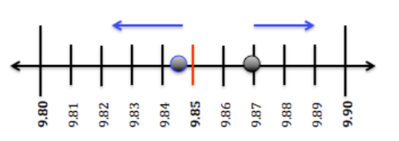

b) Write a correct inequality for the two stopwatch times using the symbols >, < 9.87 or 9.87 > 9.845

|  |  |
| --- | --- |
| **Week 3** | |
| **Fifth Grade Math Standards-Aligned Learning: Place Value Game (Addition and Subtraction) and Represent Decimal Products** | |
| **Grade Level Standard(s)** | 5.NBT.A.1 Recognize that in a multi-digit number, a digit in one place represents 10 times as much as it represents in the place to its right and 1/10 of what it represents in the place to its left.  5.NBT.B.7 Add, subtract, multiply, and divide decimals to hundredths, using concrete models or drawings and strategies based on place value, properties of operations, and/or the relationship between operations; assess the reasonableness of answers using estimation strategies. (Limit division problems so that either the dividend or the divisor is a whole number.) |
| **Caregiver Support Option** | Students must understand the place value system in order to be  successful in this task. As a variation on the interactive activity,  students may be given the grid and an ink pen (to prevent  changing answers). Parents can state the goal (largest sum,  smallest sum, largest difference, etc.) and draw the cards one at a  time. Students must place each number in the grid AS IT IS DRAWN  FROM THE DECK in order to meet the goal. Once the number is  placed, students cannot change the placement. This variation  requires not only an understanding of place value but also a basic  understanding of probability (knowing how many of each digit is  left in the deck and the probability that a particular digit will be  drawn). |
| **Materials Needed** | Recording sheet, pencil, number cards, |
| **Question to Explore** | How can you compare numbers and decimals? Whole numbers and decimals can be compared by analyzing corresponding place values. |
| **Student Directions** | **Place Value Game**  To play the game, draw eight number cards then use the numbers to fill in the grid.  Students can then either add or subtract the two numbers they have formed using the number cards.  **Represent Decimal Products**  Look carefully at the area models and decide which one goes with your partial products. |

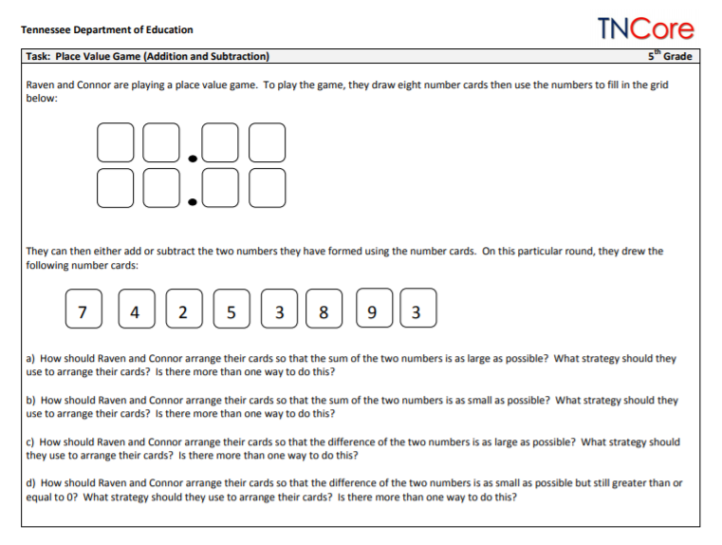

Possible Solutions

1. Part (a): To make the sum as large as possible, students need to examine the digits given and place the largest digits in the largest place values. One possible solution is:

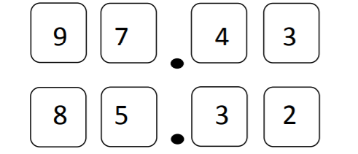

The largest possible sum is 182.75. Students may swap cards within the place value (for example, swapping the 9 and 8 cards would result in the same sum).

Part (b): This is very similar to part (a). To make the sum as small as possible, students need to examine the digits given and place the smallest digits in the largest place values. One possible solution is

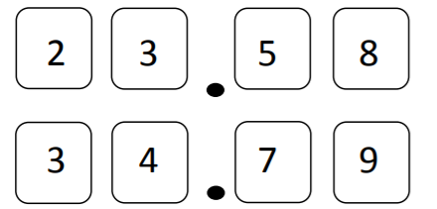

Part (c): To make the difference as large as possible, students need to examine the digits given and place the largest digits in the minuend in decreasing order and the smallest digits in the subtrahend in increasing order. The only solution is:

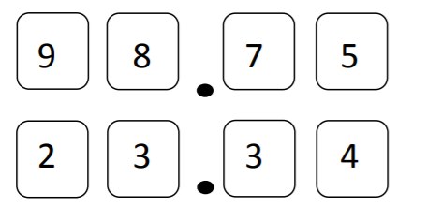

The largest possible difference is 75.41.

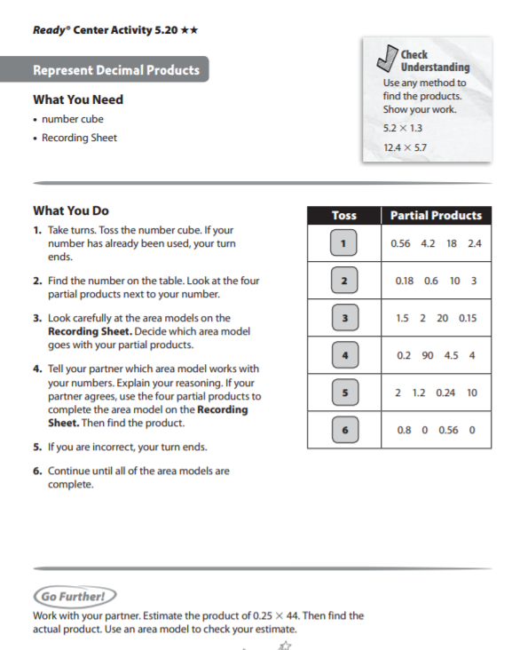

Check understanding Answer Key

6.76

70.68

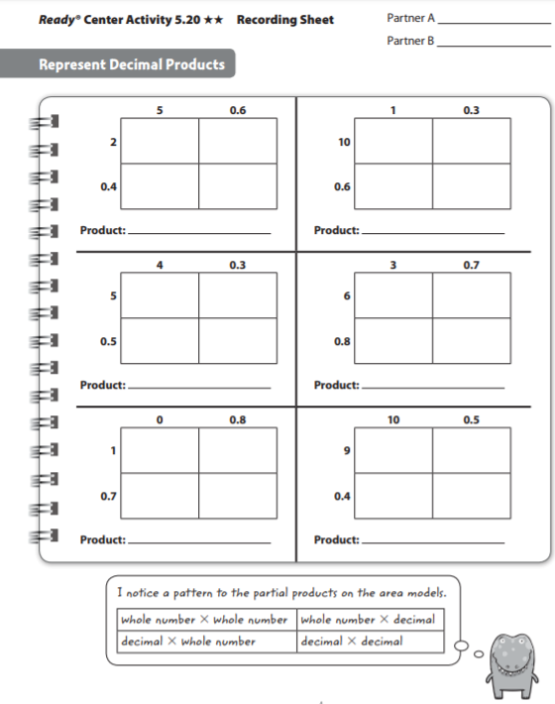

98.7

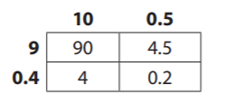

1.36

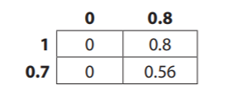

25.16

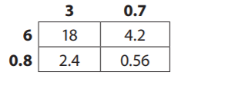

30.6

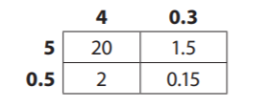

13.44

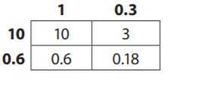

13.44

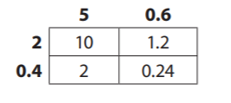

|  |  |
| --- | --- |
| **Week 4** | |
| **Fifth Grade Math Standards-Aligned Learning: Jayden’s Gym Class and Trendy T-Shirts** | |
| **Grade Level Standard(s)** | 5.NBT.A.2 Explain patterns in the number of zeros of the product when multiplying a number by powers of 10, and explain patterns in the placement of the decimal point when a decimal is multiplied or divided by a power of 10. Use whole-number exponents to denote powers of 10. |
| **Caregiver Support Option** | Encourage students to read the statements/question carefully.  Encourage students to follow the directions carefully. |
| **Materials Needed** | Recording sheet, pencil |
| **Question to Explore** | How did you choose the exponent in each expression?  Can you explain how you found the correct answer?  Is there more than one way to find the correct answer? Explain. |
| **Student Directions** | Read the problem at the top of the page. Respond to each statement/question. |

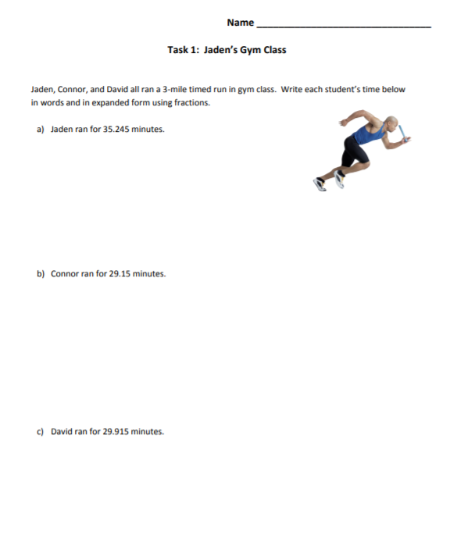

c) David’s time in word form: twenty-nine and nine hundred fifteen thousandths

David’s time in expanded form using fractions: (2 x 10) + (9 x 1) + (9 x 1 10 ) + (1 x 1 100 ) + (5 x 1 1000 )

b) Connor’s time in word form: twenty-nine and fifteen hundredths

Connor’s time in expanded form using fractions (2 x 10) + (9 x 1) + (1 x 1 10 ) + (5 x 1 100 )

WORD FORM: a) Jaden’s time in word form: thirty-five and two hundred forty-five thousandths

Jaden’s time in expanded form using fractions: (3 x 10) + (5 x 1) + (2 x 1 10 ) + (4 x 1 100 ) + (5 x 1 1000 )

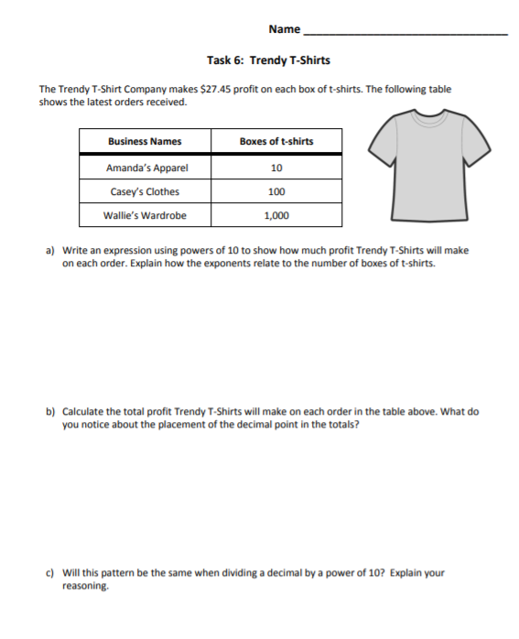

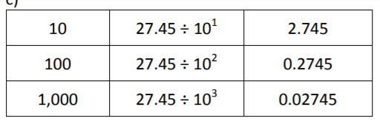

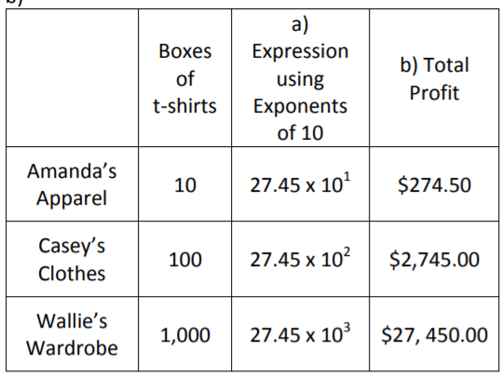

The decimal point moves to the right based on the number of zeros following the one or the value of the exponents.

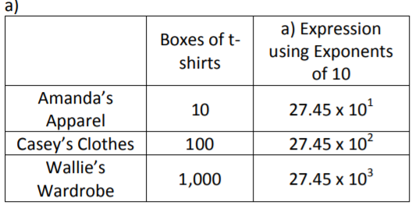

The exponent corresponds with the number of zeros in the number of boxes of t-shirts (powers of ten)

|  |  |
| --- | --- |
| **Week 5** | |
| **Fifth Grade Math Standards-Aligned Learning: Decimal Sums and Differences** | |
| **Grade Level Standard(s)** | 5.NBT.B.7 Add, subtract, multiply, and divide decimals to hundredths, using concrete models or drawings and strategies based on place value, properties of operations, and/or the relationship between operations; assess the reasonableness of answers using estimation strategies. (Limit division problems so that either the dividend or the divisor is a whole number.) |
| **Caregiver Support Option** | Students add and subtract decimals through hundredths. They  apply the standard algorithm for addition and subtraction t  decimals. By using visual models such as place-value charts,  number lines, and base-ten models, they conceptualize adding  and subtracting decimals. |
| **Materials Needed** | Recording Sheet, pencil |
| **Question to Explore** | How does using expanded form in words help you add  decimals? Using expanded form helps understand the  relationship of place value to the addition process and the  importance of adding hundredths and hundredths, tenths and  tenths. Expanded form helps avoid place value errors, such as  adding tenths and hundredths instead of tenths and tenths. |
| **Student Directions** | **Decimal Sums and Differences**  Use number sense, estimation, or mental math to decide if the equation is true or false. Explain your reasoning to your partner.  Have a partner check your work by simplifying both sides of the equation.  Write the equation in the correct column on the recording sheet. |

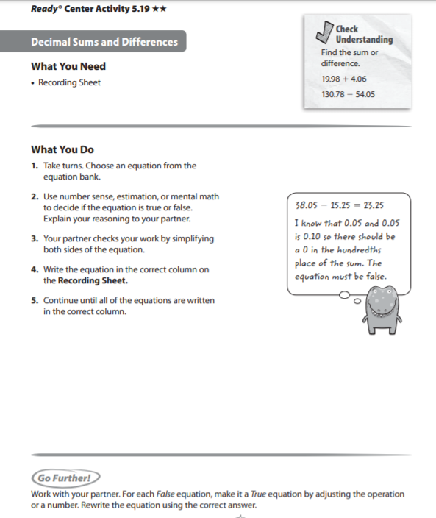

Check Understanding Answer Key

24.04

76. 73

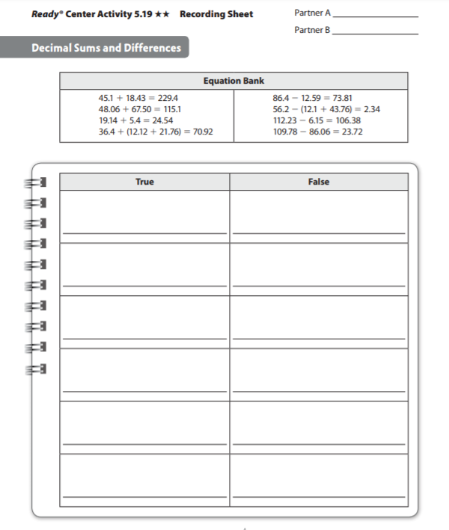

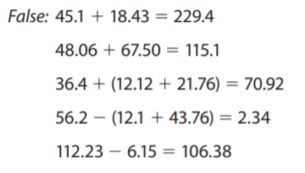

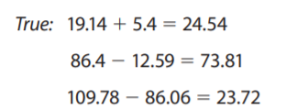

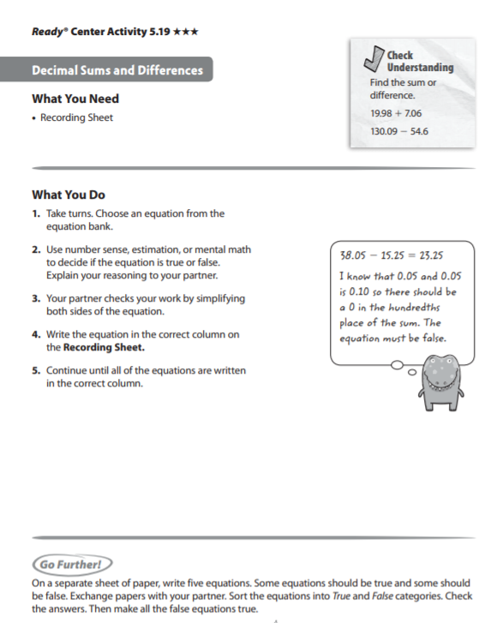

Check Understanding Answer Key

27.04

75.49

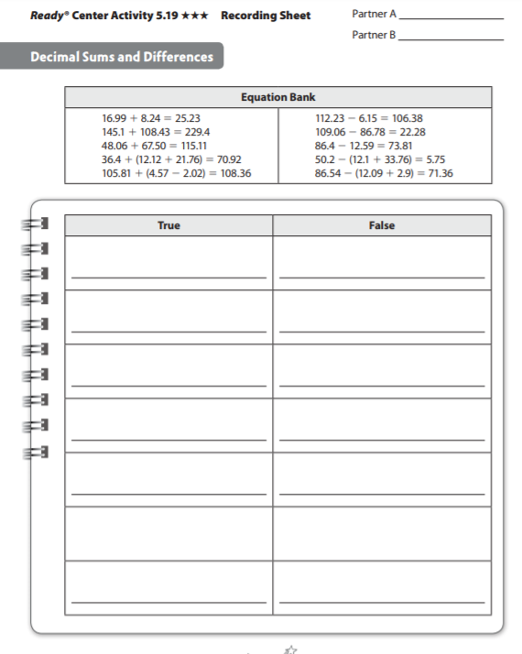

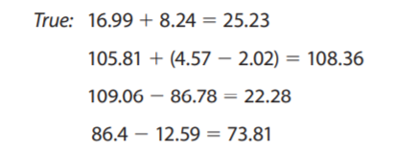

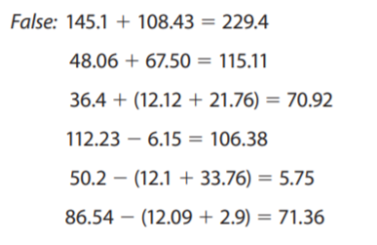

|  |  |
| --- | --- |
| **Week 6** | |
| **Fifth Grade Math Standards-Aligned Learning: Ten Times as Much as or One-Tenth of and Less than, Equal to, Greater than** | |
| **Grade Level Standard(s)** | 5.NBT.A.1 Recognize that in a multi-digit number, a digit in one place represents 10 times as much as it represents in the place to its right and 1/10 of what it represents in the place to its left.  5.OA.A.1 Use parentheses and/or brackets in numerical expressions and evaluate expressions having these symbols using the conventional order (Order of Operations). 5.OA.A.2 Write simple expressions that record calculations with numbers and interpret numerical expressions without evaluating them. For example, express the calculation "add 8 and 7, then multiply by 2" as 2 x (8 + 7). Recognize that 3 x (18,932 + 921) is three times as large as 18,932 + 921, without having to calculate the indicated sum or product. |
| **Caregiver Support Option** | They use grouping symbols (parentheses and fraction bars) to  evaluate and write numerical expressions, such as 2 x (5 + 8), in  order to find solutions to problems. They recognize the importance  of the placement of parentheses and understand that numerical… |
| **Materials Needed** | Recording sheet, pencil |
| **Question to Explore** | What is the order of operations? Students’ responses should  indicate an understanding that multiplication and division are  performed before addition and subtraction.  How does division relate to multiplication when finding the value  of each place in a number? Students have learned that each  place value is ten times the value of the place to its right. Listen  for students understanding that division is the inverse of  multiplication and reasoning that if the value of one place is  equal to the value of the place to the left divided by 10.  Encourage students to ask questions and explain their ideas. |
| **Student Directions** | **Ten Times as Much as or One-Tenth of**  Look at the number in the second column. Decide if that number is 10 times as much as (or 1/10 of ) your number. Explain your reasoning. |

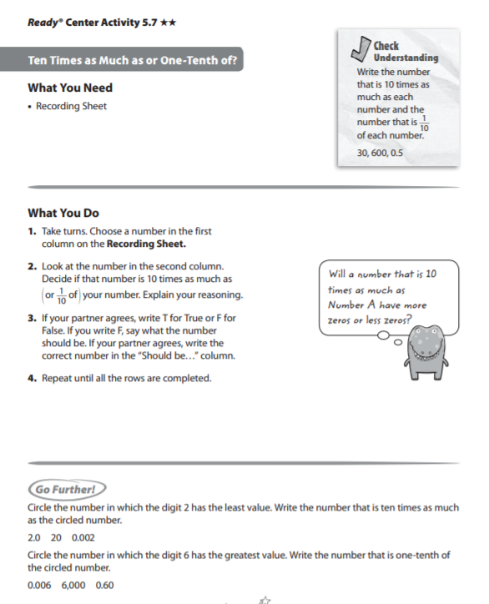

Check Understanding Answer Key

30:300, 3; 600: 6,000, 60; 0.5: 5, 0.0

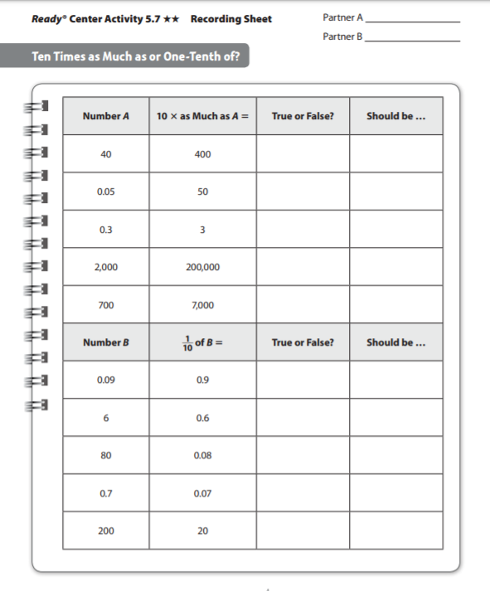

8

0.009

200:T

0.7:T

80:F

6: T

0.09: F

700:T

20,000

2,000 :F

0.3: T

0.5

40: T

0.05: F

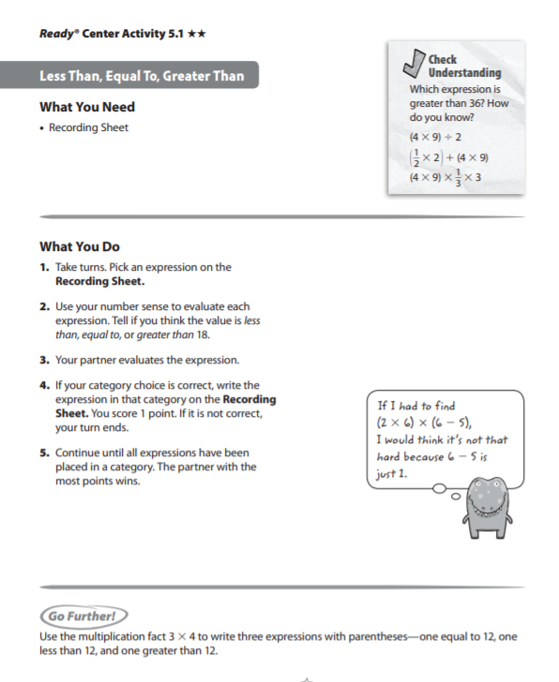

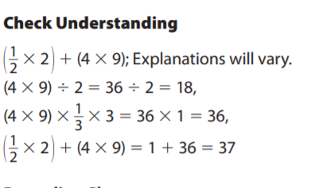

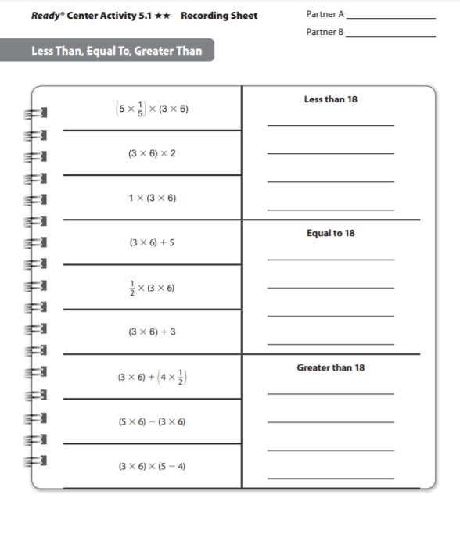

(5 x 1/5 x (3 x6)

1 x (3 x6)

(3 x 6) x (5-4)

½ x (3 x6)

(3 x6) ÷ 3

( 5 x 6) – (3 x 6)

(3 x6) x2

(3 x 6) + 5

(3 x 6) + (4 x ½)

|  |  |
| --- | --- |
| **Week 7** | |
| **Fifth Grade Math Standards-Aligned Learning: Using Multiplication Vocabulary and Equivalent Multiplication Expressions** | |
| **Grade Level Standard(s)** | 5.NBT.B.5 Fluently multiply multi-digit whole numbers (up to three-digit by four-digit factors) using appropriate strategies and algorithms. |
| **Caregiver Support Option** | Students are exposed to multiply fluently using the standard  algorithm. Students will need to be able to multiply fluently using the  standard algorithm when they learn to multiply decimals. |
| **Materials Needed** | Recording Sheet |
| **Question to Explore** | How does the area model help you solve the problem? It shows a  picture of the product and breaks apart the factors to easily  identify them and help find the partial products.  Why is it okay to add the partial products? The area model shows  that the sum of the partial products is the total area, or the entire  product. |
| **Student Directions** | **Use Multiplication Vocabulary**  Read the problem on the Recording Sheet. Read the paragraph that tells how to solve the problem. Use word from the word bank to fill in the blank.  **Equivalent Multiplication Expressions**  Pick an expression in the table. Decide if the expression is equivalent to the multiplication expression in the header row. Use any method to determine if the expressions are equivalent. |

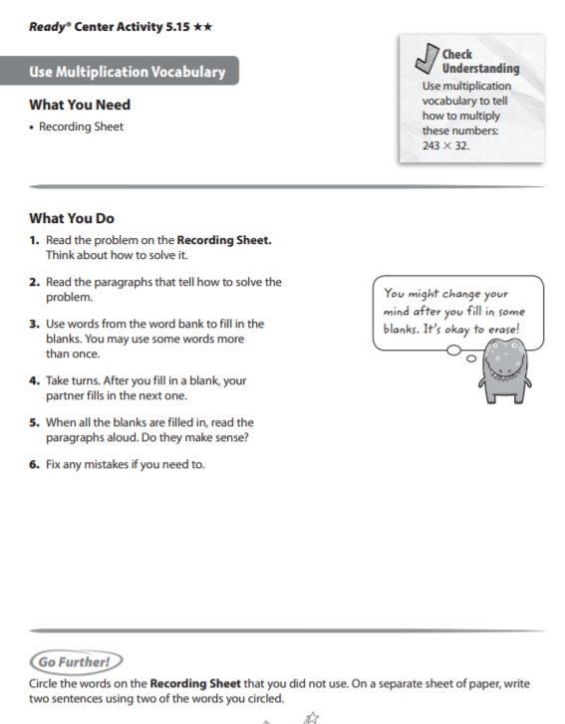

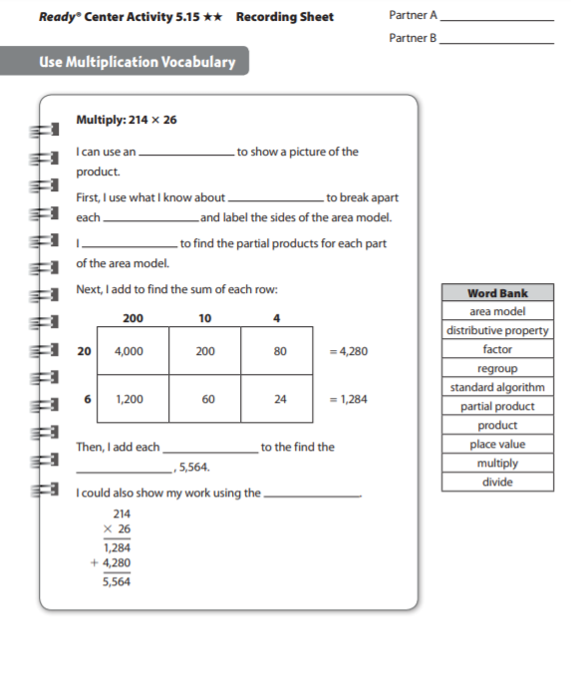

Answer key

Area Model

Place Value

Factor

Partial Product

Standard algorithm

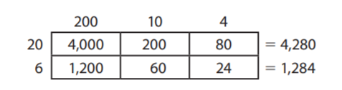

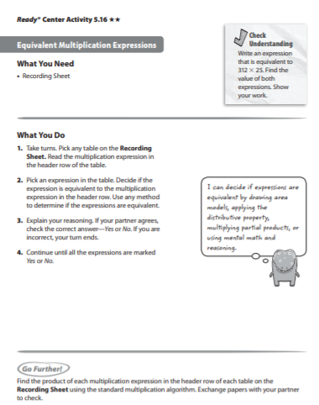

Check Understanding Answer Key

7,800

(300 x 20) + (300 x 5) + (10 x 20) + (10 x 5) + (2 X 20) + (2 x 5)

(300 x 25) + (12 x 25) ; 1,560 + 6,240

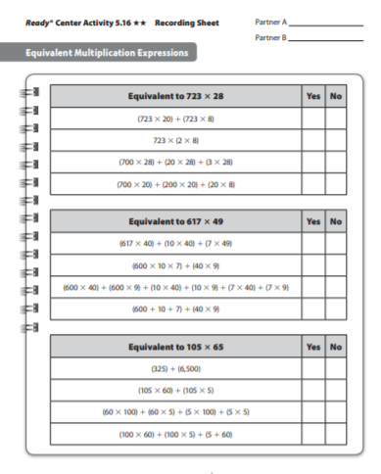

ANSWER KEY

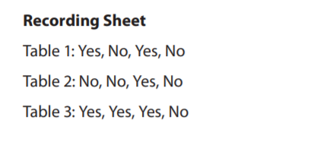

|  |  |
| --- | --- |
| **Week 8** | |
| **Fifth Grade Math Standards-Aligned Learning: Represent Decimal Products** | |
| **Grade Level Standard(s)** | 5.NBT.B.7 Add, subtract, multiply, and divide decimals to hundredths, using concrete models or drawings and strategies based on place value, properties of operations, and/or the relationship between operations; assess the reasonableness of answers using estimation strategies. (Limit division problems so that either the dividend or the divisor is a whole number.) |
| **Caregiver Support Option** | Students multiply decimals through hundredths. They use  connections between patterns in decimal multiplication and whole  number multiplication. They expand their previous conceptual  understanding of multiplication by using decimals grids and area  models to multiply tenths and hundredths decimals. |
| **Materials Needed** | Recording sheet, number cube |
| **Question to Explore** | Why do you estimate the product? Estimating the product helps  you know how much the actual product should be.  Look at your estimate and look at the product you found. Does  the answer make sense? How can you tell? The product ___  makes sense because it is close to the estimate of ___. |
| **Student Directions** | Find the number on the table. Look at the four partial products next  to your number. Look carefully at the area models on the Recording  Sheet. Decide which area model goes with your partial products. |

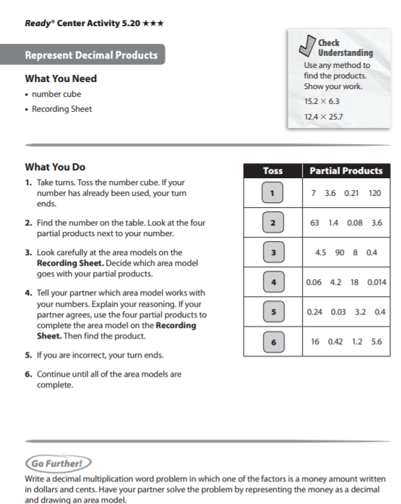

Check Understanding Answer Key

95.76

318.68

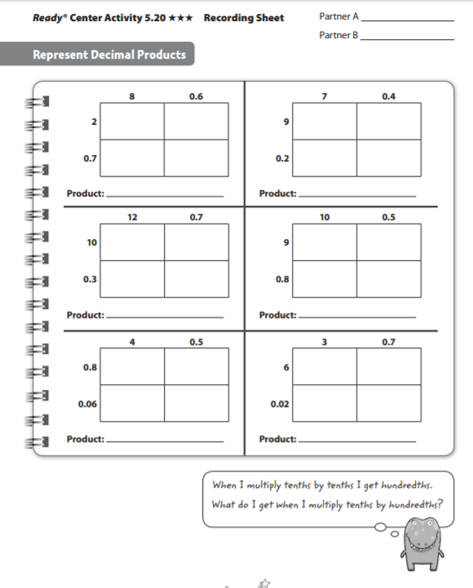

22.274

3.87

102.9

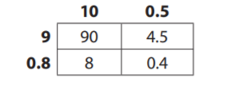

130.81

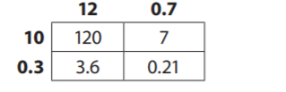

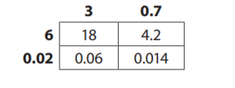

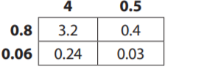

68.08

23.22

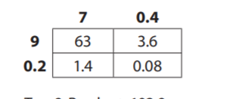

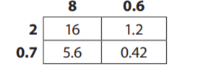

|  |  |
| --- | --- |
| **Week 9** | |
| **Fifth Grade Math Standards-Aligned Learning: Quiz** | |
| **Grade Level Standard(s)** | 5.MD.A.1 Convert customary and metric measurement units within a single system by expressing measurements of a larger unit in terms of a smaller unit. Use these conversions to solve multi-step real-world problems involving distances, intervals of time, liquid volumes, masses of objects, and money (including problems involving simple fractions or decimals). For example, 3.6 liters and 4.1 liters can be combined as 7.7 liters or 7700 milliliters. |
| **Caregiver Support Option** | Encourage the students to read each question carefully. Remind the  students to show his/her work. Remind students to use the RDW  process when solving word problems- Read the problem, Draw a  model, and Write an equation and sentence. |
| **Materials Needed** | Lesson 21B Quiz, paper |
| **Question to Explore** | Why do you multiply to convert a larger unit to a smaller unit?  Students may explain that one larger unit is equivalent to a group of  smaller units. Each group of smaller units is a set. Multiplication is  the operation of finding the total of a set of equal numbers. |
| **Student Directions** | Read each problem and solve. |

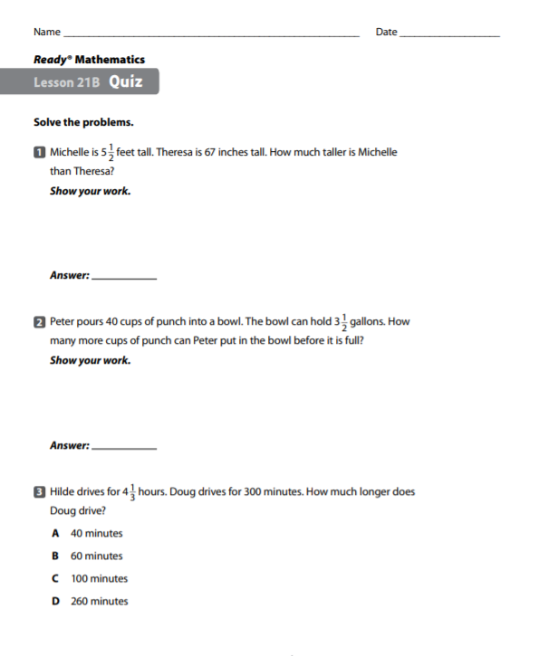

A

